1

Givesas

Has

User

User-ID

e-Mail

Mobile no.

Name

Many

1

Can Buy

Has

1

1

Tickets

Ticket-ID

User-Id

Seat-No.

Show time

Payments

Payment-Id

Payment-Mode

Amount

Ticket-Id

FK

Status

Many

Have

Many

1

Has

Have

Shows

Morning

1st show

2nd show

Matinee

Seats

Seat-ID

Status(Booked/Available)

Show Time

Many

1

1

Many

Movie

Movie name

Language

Duration

Genre

Rating

1

Theatres

Theatre-Name

Seating Capacity

Location

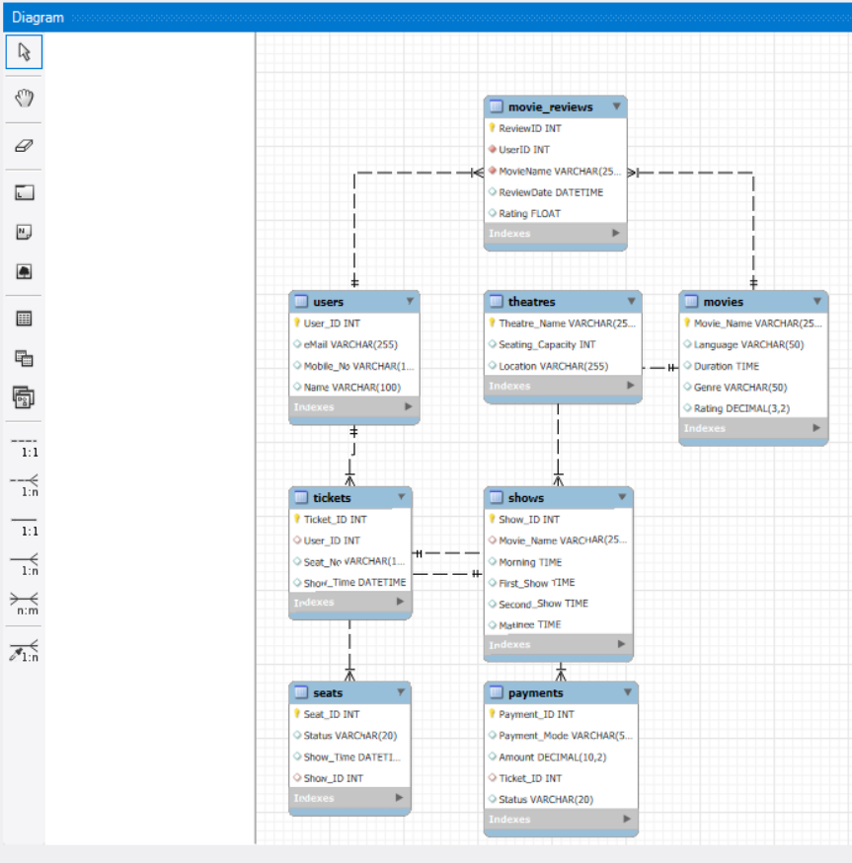

**Foreign Keys:**

* Movie-Name
* Ticket_id
* User_id
* Rating

Movie Review

Review-Id

Movie-Name

Review Date

user-Id

Rating

1

1

1

Hasas